Monday 6th June 2023
L.O. – I can write an explanation about a current affair
UNCRC Article 28 – Right to Education

Look at the images below.
- Where could these images be?

- What issues can be seen from the 3 images?

- Can you give 3 facts for each image?

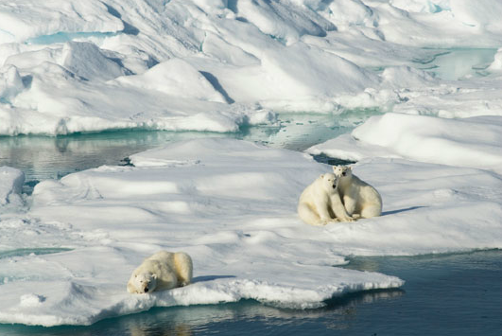

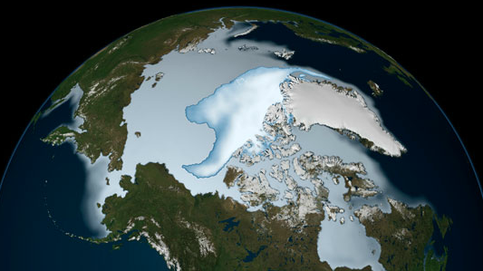

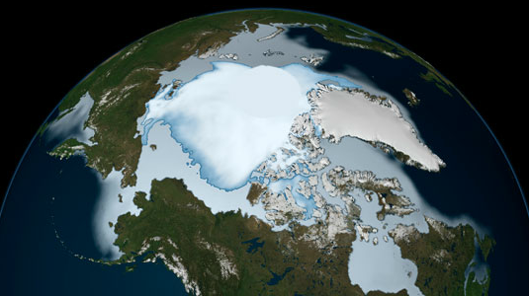

- Can you give 3 opinions for each image?

- Do you know where this is? How do we know that it is the Arctic and not the Antarctic?
(Polar bears live in the Arctic but not the Antarctic.)

- What is the Arctic Circle is, and where it is?

- Can you find it on a globe (also the Antarctic Circle and the continent of Antarctica).
Explain that Antarctica has a large area of land: it is a continent, but the Arctic is not.

- Read the report ‘On Thin Ice’.

Can you make brief notes to summarise the report.

