Name:_______________________ Monday 19th June 2023
Class 5 Homework – Science
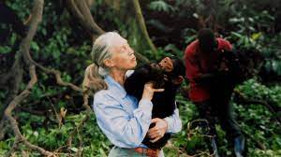
Jane Goodall and Animal Behaviour
Have you ever owned a cuddly toy? What kind was it? Did you have different types?
What was their names?
Your homework is about a scientist who had a toy chimp called Jubilee. The scientist is called Jane Goodall – she was born in 1934.
- Are you fascinated by animals?
- Has your opinions changed about animals as you have grown up?
Read the extract ‘Dame Jane Goodall’.
- Can you give a brief summary that explains the key events of the extract?
- Can you write a brief explanation about a family pet of your own, like Jane Goodall did?

