Science Homework – Animals Including Humans – Alnwick – 25.9.23

Q1.
Human life cycle and pulse rate
(a) Ella is learning about the human life cycle.
She collects pictures of people of different ages.
Label the photographs to name stages B and D in the human life cycle.
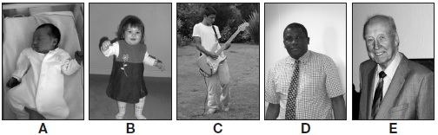
baby ____________ teenage ____________ old age
1 mark
(b) Ella wonders if pulse rate is affected by the different stages in the human life cycle.
Complete the sentence below about pulse rate.
Pulse rate measures how quickly the ____________ pumps blood around the body.
1 mark
(c) Ella measures the resting pulse rate of people from each of the life stages.
Ella’s test would not be fair if she measured some people’s pulse rates after they were exercising instead of after resting.
Explain why.
___________________________________________________________________
___________________________________________________________________
1 mark
(d) The table shows Ella’s results.

Stage of the human life cycle | Average resting pulse rate (beats per min)
A (baby) | 135
B | 97
C | 84
D | 72
E (old age) | 76
Ella concludes, ‘The older you are, the slower your resting pulse rate is.’
The evidence in Ella’s results does not support her conclusion.
Use Ella’s results to explain why they do not support her conclusion.
___________________________________________________________________
___________________________________________________________________
1 mark
(e) People who are fit have lower resting pulse rates than people who are unfit.
Write yes or no on each row of the table to show if the activities are likely to affect a person’s resting pulse rate.

 | Activity | Will the activity affect a person’s resting pulse rate? Yes or no?
 | swim every day
 | go for a walk every day
 | read every day
1 mark

Q2.
Sports day
(a) Dan has some ideas about exercise.
Write true or false under each statement about exercise.
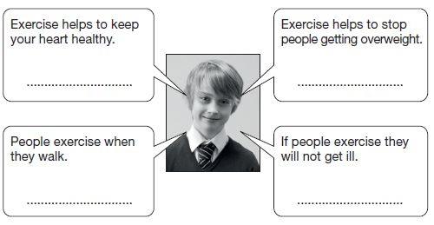
2 marks
(b) Leg muscles and bones help people to run and move.
Leg bones are part of the skeleton.
Other than movement, describe another function of the skeleton.
........................................................................................................................
1 mark
(c) Dan wins the 100 m race at his school’s sports day. He gets a medal.

The school’s medals are made  of steel or plastic.  They are all the same size,  shape and colour.  Dan tests his medal to find  out if it is steel or plastic. | 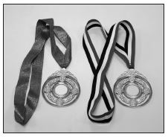
Will each test show if Dan’s medal is steel or plastic?
Write yes or no in each row of the table below.
Test | Will the test show if Dan’s medal is steel or plastic?  Yes or no?
Hold a magnet next to
each medal.
Put each medal in an electric circuit with a bulb and cell.
Drop some water on each medal.
Weigh each medal.
Shine a light on each medal.
2 marks
Q3.
Pulse rate
(a) Class 6 are learning about the human body.
Complete the sentences below using the words in the box.
The ............................... pumps blood around the body.
The ............................... carry blood around the body.
The ............................... protect the heart.
1 mark
(b) Your pulse rate tells you how fast your heart is beating.
Tick ONE box to show what equipment you could use to workout your pulse rate.
ruler |  | forcemeter
stopwatch |  | thermometer
1 mark
(c) Class 6 have some ideas about pulse rate.
Write true or false next to each statement about pulse rate.
 | True or false?
Different types of exercise can affect pulse  rate by different amounts. | ......................
Different people can have different resting pulse rates. | ......................
A high pulse rate means the heart is beating fast. | ......................
1 mark
(d) Class 6 investigate the effect of exercise on pulse rate.
They measure Emily’s pulse rate three times:

1. at rest.  2. straight after running for  10 minutes.  3. after resting for 20 minutes. | 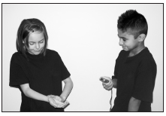
Look at the table of results below.
Some of Emily’s pulse rates are missing.
Complete the table of results by predicting Emily’s pulse rates straight after running and after resting for 20 minutes.
 | At rest before running | After running for 10 minutes | After resting for 20 minutes
Pulse rate (heart beats per minute) | 90 | ...................... | ......................
1 mark
(e) Class 6 think of some questions about the heart and exercise.
Tick THREE boxes to show which questions the class could investigate by doing a fair test.
Where is the heart found in the body?
How does age affect a person’s heart rate?
How does the heart work?
What does the heart look like?
Do tall people have faster pulse rates than short people?
Do people who exercise regularly eat more food than people who do not exercise?
2 marks
Q4.
Health and digestion
(a) Josh is finding out about the digestive system.
Tick ONE box to show why we need a digestive system.
Tick one.
To control how the body moves. |  | To give support to the body.
To break down food for the body to absorb. |  | To transport blood around the body.
1 mark
(b) Josh has some cards labelled with parts of the digestive system.
Write 1 to 5 to show the correct path through the parts of the digestive system. The first one has been done for you.

mouth |  |  | large intestine |  |  |  | oesophagus
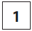
 | small intestine |  |  |  | stomach
1 mark
(c) The girl below is wearing an apron to show parts of the digestive system.
Draw an X to show the part that is the stomach.
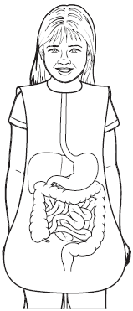
1 mark
(d) Complete the sentences below by writing the correct words on the answer lines.
Water and nutrients pass from the small intestine into
the .................................................... .
They are then transported around the body by the
.................................................... system.
1 mark
(e) To keep our bodies functioning well we need to eat a balanced diet.
Another way to keep healthy is by exercising.
Give TWO ways in which exercise can help keep our bodies functioning well.
1. ...................................................................................................................
2. ....................................................................................................................
1 mark

