Science Homework – Animals Including Humans – Raby – 25.9.23

Q1.
Growth and health
(a) Sue writes down some different stages of the human life cycle.

Some stages of the human life cycle
A adult B old age C toddler
D teenager E newborn
Write the correct letter (A–E) in each box on the chart below to order the stages of the human life cycle from youngest to oldest.
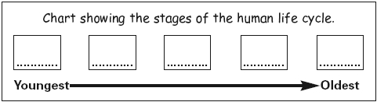
1 mark
(b) Sue describes some of the stages of the human life cycle in the table below.
Which stages of the human life cycle (A, B, C, D or E) are being described? Write ONE letter next to each description.
Stage  (write the letter) | Description of stage
............ | ■ has just learned to walk  ■ is learning to talk  ■ is learning to use a toilet
............ | ■ body gets taller quickly and changes shape  ■ more body hair starts to grow  ■ may get spots (acne)
1 mark

(c) There are different life processes that humans do.
Complete the table below to show the missing life processes and evidence. One row of the table has been done for you.
Life process | Evidence of the life process
growth | People get taller.
.................................. | People walk.
nutrition | People ..................................
.................................. | People have babies.
2 marks
(d) Sue knows that what you eat can help you live a healthy life.
(i) What is best for Sue to do to help her have a healthy diet? Tick ONE box.
Sue should...

not eat sugary foods. |  | eat a variety of different foods.
not eat foods that contain fat or oil. |  | eat only fruit.
1 mark
(ii) Sue eats the best foods to give her a healthy life.
Give ONE other way Sue could keep her body healthy.
...............................................................................................................
1 mark

Q2.
Growing up
(a) Adam has collected the pictures below. They show different stages in the life of his grandmother.
Write a number from 1 to 6 in each box to put the life stages in order from youngest (1) to oldest (6).
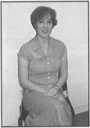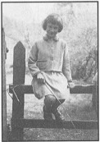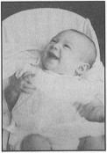
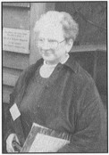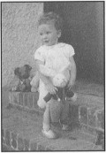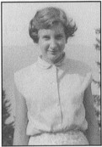
1 mark
(b) Growth is a life process of all living things.
Name TWO other life processes of all living things.
1. ............…......................................…
1 mark
2. ..............….......................................
1 mark
(c) The graph below shows how Adam has grown in height.
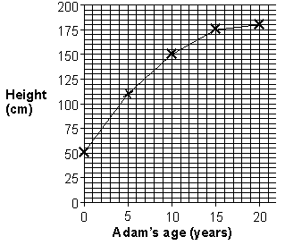
How tall was Adam on his fifth birthday?
..................................................... cm
1 mark
(d) Tick ONE box to show when Adam grew most quickly in height.
0–5 years |  | 5–10 years
10–15 years |  | 15–20 years
1 mark
(e) Continue the line on the graph below to predict Adam’s height between 20 and 30 years old.
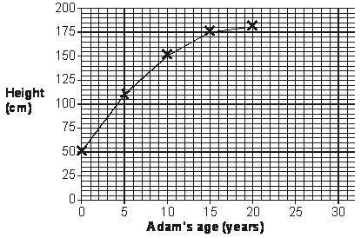
1 mark

