The Railway Children

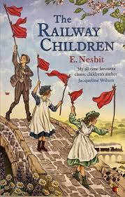
- What do you know about The Railway Children?
- When and where was the book set?
- What genre of books would you place this book?

Using research skills can you create a poster explaining key elements to The Railway Children and what was significant to this time period?

Can you structure your poster using appropriate:
- Headings
- Subtitles
- Images
- Captions

- Have you read The Railway Children?

- Would you recommend this book to anyone?

