Class 5 – Alnwick – Homework – 16th October 2023 Name:______________________________
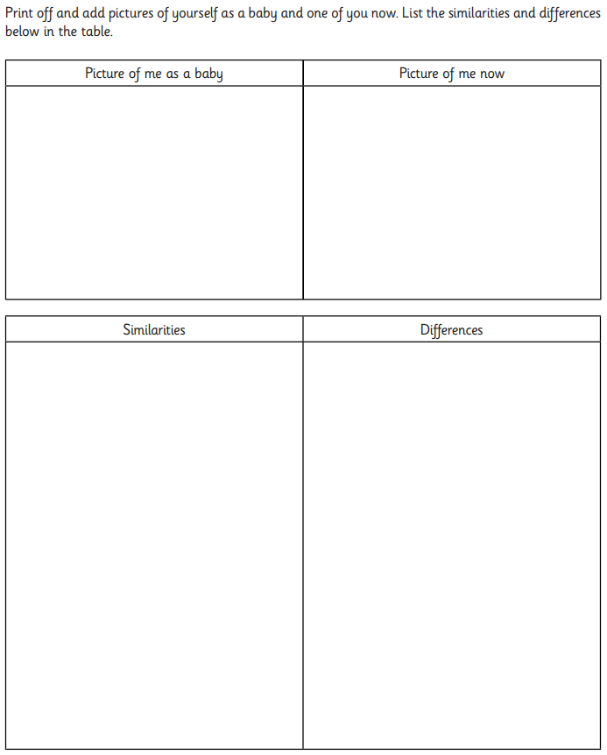

Health and digestion
(a) Josh is finding out about the digestive system.
Tick ONE box to show why we need a digestive system.
Tick one.
To control how the body moves. |  | To give support to the body.
To break down food for the body to absorb. |  | To transport blood around the body.
1 mark
(b) Josh has some cards labelled with parts of the digestive system.
Write 1 to 5 to show the correct path through the parts of the digestive system. The first one has been done for you.

mouth |  |  | large intestine |  |  |  | oesophagus
 | small intestine |  |  |  | stomach
1 mark
(c) The girl below is wearing an apron to show parts of the digestive system.
Draw an X to show the part that is the stomach.
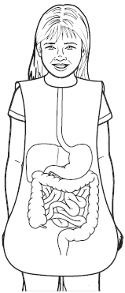
1 mark
(d) Complete the sentences below by writing the correct words on the answer lines.
Water and nutrients pass from the small intestine into
the .................................................... .
They are then transported around the body by the
.................................................... system.
1 mark
(e) To keep our bodies functioning well we need to eat a balanced diet.
Another way to keep healthy is by exercising.
Give TWO ways in which exercise can help keep our bodies functioning well.
1. ...................................................................................................................
2. ....................................................................................................................
1 mark

