Class 5 – Homework – Bamburgh - 9.10.23

Solve the calculations below using an appropriate written method to show your workings

1). 93862.2 + 2173.4 =
2). 934862 - 6485.31 =
3). 10233.4 - 9834.6 =
4). 839501 + 300912 =
5). 2945.3 - 1920.1 =

Q6.
You can make green paint by mixing:
• 250 ml of blue paint
• 1,150 ml of yellow paint.
Stefan wants to make some of this green paint.
He uses 750 ml of blue paint.
How much green paint does he make?

Q2.
Adam buys 4 pens and a ruler and pays £4.75 altogether.
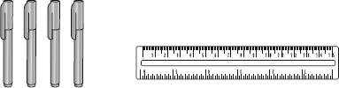
Jack buys 2 pens and pays £1.98 altogether.
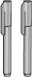
How much does a ruler cost?

Q3.
Ally chooses a whole number.
When she multiplies her number by 4, the answer is less than 100
When she multiplies her number by 5, the answer is greater than 100
Write a number that Ally could have started with.

