Class 5 – Bamburgh – Homework – 16th October 2023 Name:______________________________
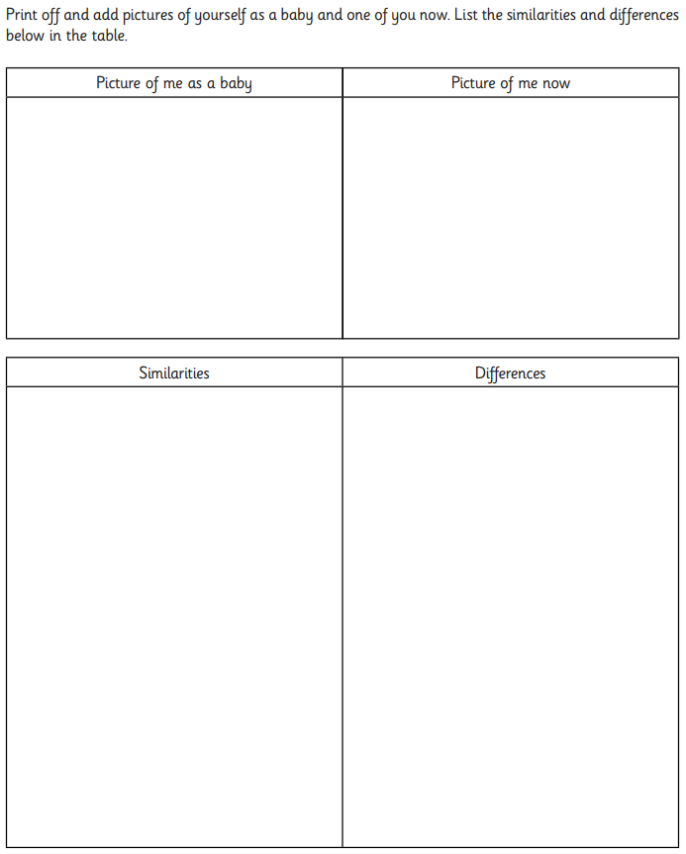

Human body
(a) Rohan is wearing an apron showing different parts of the body.
(i) Tick ONE box to show which body part is the heart.
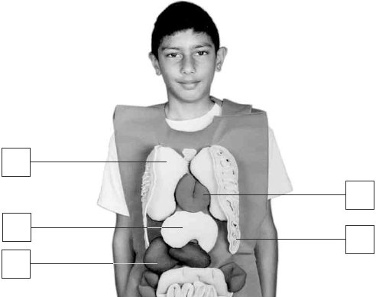
1 mark
(ii) Describe the function of the heart in the human body.
...............................................................................................................
...............................................................................................................
1 mark
(b) Rohan thinks about other parts of the human body.
Which of these things would do most damage to the lungs?
Tick ONE box.
drinking alcohol |  | smoking cigarettes
eating fatty food |  | not exercising
1 mark
(c) Why does brushing teeth help to reduce tooth decay?
.......................................................................................................................
........................................................................................................................
1 mark
(d) Complete each sentence using a word from the box below it.
(i) The skeleton is moved by the ......................................... when
the body moves.
legs arms bones muscles
1 mark
(ii) The bones in the skeleton are ...................................... so that
they can support the body.
straight long rigid curved
1 mark

