Class 5 – Lindisfarne – Homework – 16th October 2023 Name:______________________________
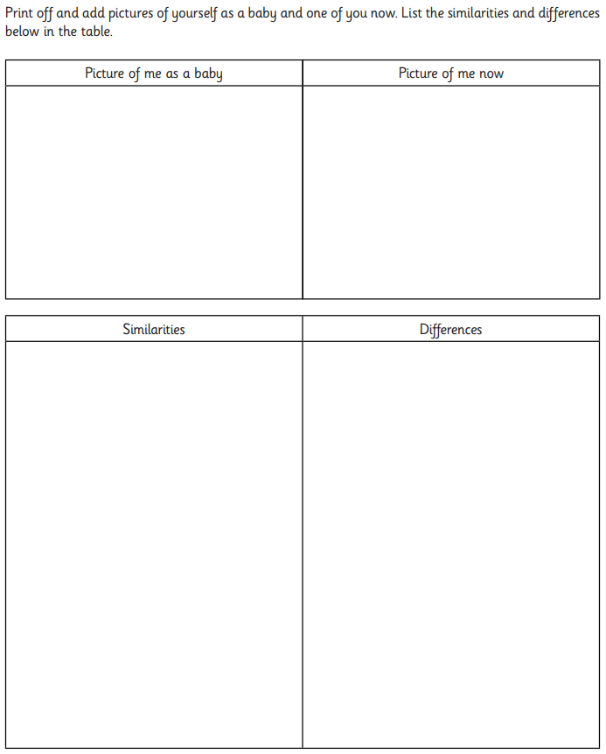

Teeth
(a) Rosie is doing a survey about canine teeth. She counts the number of adult canine teeth each pupil in year 4 has. She also counts the number of adult canine teeth each pupil in year 6 has.
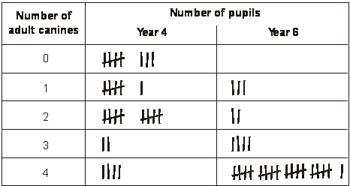
How many pupils in year 4 have only two adult canine teeth?
....................................................pupils
1 mark
(b) Rosie draws the bars for year 4 and year 6 on the graph below to show her results. She has not shaded in the bars for year 6.
Shade in the bars for year 6 on the graph below. Use the key and table to help you.
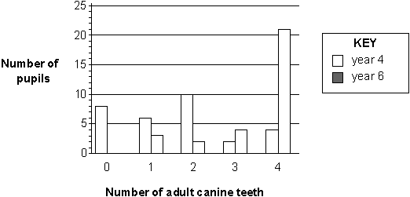
1 mark
(c) Rosie knows that to keep her teeth healthy she should not eat too many sweets and other sugary foods.
Name ONE other thing that Rosie can do to help her teeth healthy.
.......................................................................................................................
1 mark
(d) Different teeth have different functions when we eat food.
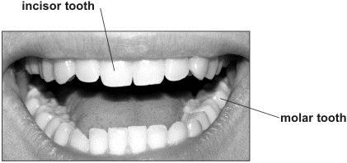
What function do the incisor teeth have that molar teeth do not?
.......................................................................................................................
1 mark
(e) Write true or false next to each of the statements below.
True or false?
Children lose their first teeth and grow new teeth. .........................
Human teeth can reproduce. ..........................
1 mark

