Class 5 – Lumley – Homework – 16th October 2023 Name:______________________________
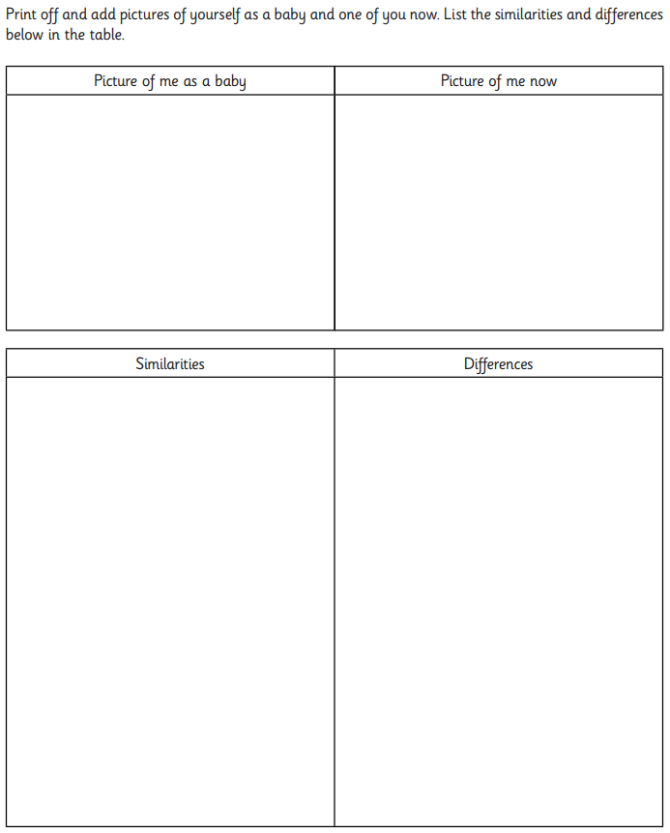

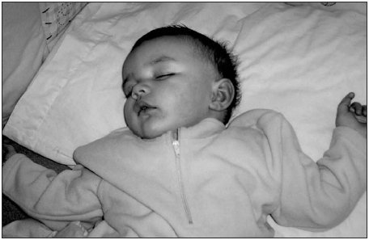
Sleeping babies
(a) Scientists have found out that babies who spend more time in daylight sleep better at night.

To test their idea, the scientists needed to find out how well some babies sleep at night normally.
What could the scientists measure or observe to find out how well babies sleep?
.......................................................................................................................
.......................................................................................................................
1 mark
(b) The scientists asked the parents to increase the time their babies spend in daylight. They measured how well the babies slept again.
Write yes or no next to each statement to show how parents could increase the time their baby spends in daylight.
Would the baby
spend more time
Parents could... in daylight?
play with the baby more often in the garden. .......................
keep the curtains closed in the baby’s room. .......................
take the baby for a walk in the pram. .......................
2 marks
(c) The parents must be careful that the sunlight does not burn the baby.
Describe ONE way parents can keep babies safe in sunlight.
.......................................................................................................................
1 mark
(d) To test their idea, the scientists needed to do the test with more than one baby.
Explain why they needed to do the test with more than one baby.
.......................................................................................................................
.......................................................................................................................
1 mark

