Class 5 – Raby – Homework – 16th October 2023 Name:______________________________
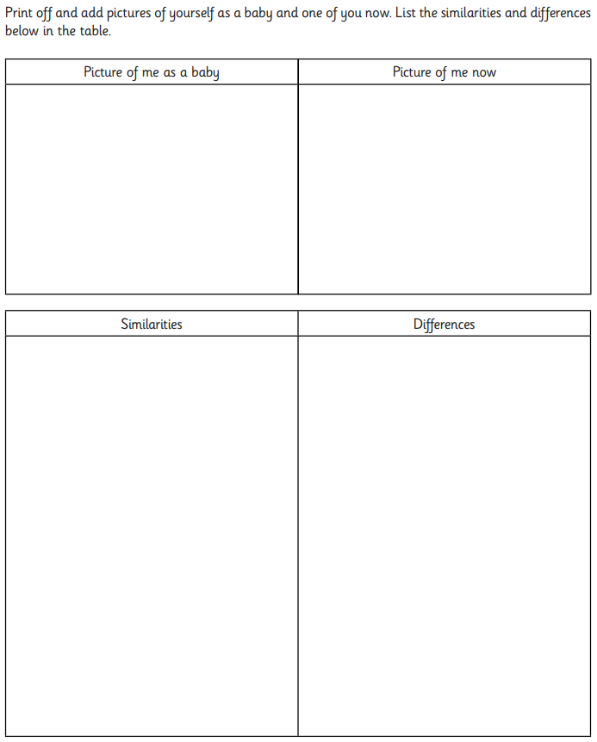

Teeth
(a) Sue wants to find out how four different drinks affect teeth.
Egg shell and teeth are made of the same type of material.
Sue puts the same amount of egg shell in four beakers.
She puts a different drink into each beaker.
Show how much drink Sue must put in each beaker for her test to be fair. Draw a line on beakers B, C and D.
Beaker A has been done for you.
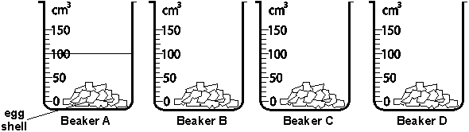
1 mark
(b) After six days, Sue looks in the beakers.
Beaker C has the least amount of egg shell left in it.
Tick ONE box to show which drink is most likely to be in beaker C.
lemonade |  | milk
tea |  | water
1 mark
(c) Sue decides to drink less of the drink in beaker C to help stop tooth decay.
Give TWO other ways Sue can help stop tooth decay.
(i) .............................................................................................................
1 mark
(ii) .............................................................................................................
1 mark

(d) The shape of animals’ teeth can be different because they eat different things.
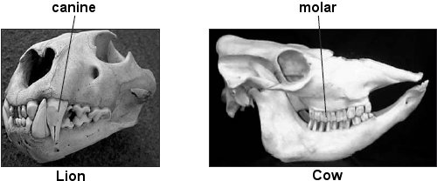
Lion skull – reproduced by kind permission of Ipswich Borough Council Museums
and Galleries. Cow skull – reproduced by kind permission of D. Roberts.
A lion has long, sharp canine teeth for eating meat.
(i) How do canine teeth help the lion to eat meat?
...............................................................................................................
1 mark
A cow has large, flat molar teeth for eating grass.
(ii) How do molar teeth help the cow to eat grass?
...............................................................................................................
1 mark

