Monday 13th November 2023 – Bamburgh Homework – LIVING THINGS
Q1.
Duck pond
(a) Peter goes to the duck pond with his grandad and his dog.
Tick TWO boxes to show two things that are true about a dog and a duck.
They both have fur. |  | They both move.
They both lay eggs. |  | They both breathe.
1 mark
(b) Two of the ducks come out of the pond.
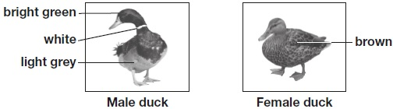
(i) Describe how a duck’s feet are adapted for swimming.
______________________________________________________________
1 mark
(ii)
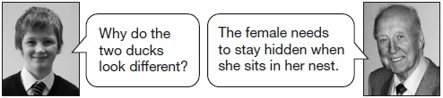
Why would the female duck be hard to see in a nest?
______________________________________________________________
1 mark
(iii) Explain why the female duck needs to stay hidden when she is in her nest.
______________________________________________________________
1 mark

(c) Peter sees some piles of soil on the grass near the pond.
Grandad tells him that the piles of soil are made by animals called moles.
Look at the picture of a mole.
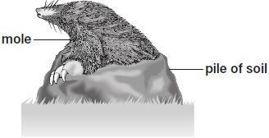
(i) Describe how a feature of the mole helps the mole to live underground.
Feature: _______________________________________________________
How it helps: ___________________________________________________
1 mark
(ii)
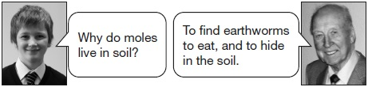
Which word cannot be used to describe a mole?
Tick ONE box.
prey producer predator consumer
1 mark
Q2.
Plants on the school field
(a) Some children are finding out about plants. They get three buttercup plants. They put each plant in a place with different conditions.
After two weeks, the buttercup plants look like this:
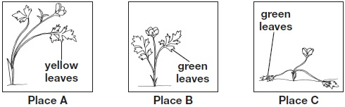
Write A, B, and C in the table below to match each place to the conditions found there.
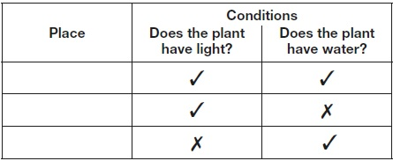
1 mark
(b) There are differences between plants.
These differences help people sort plants into groups.
Write true or false next to each reason that explains why plants need to be sorted into groups.

 | Plants need to be sorted into groups... | True or False?
 | to stop plants becoming extinct. | ____________
 | to help people identify plants | ____________
 | to help plants reproduce. | ____________
1 mark
(c) The children look at different plants on the school field.
They record the number of common plantain and buttercup plants in 1m² in different places. | 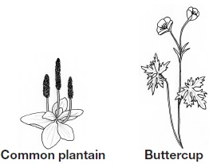
The children think they see a pattern in the place that the plants grow.
The table shows their results.
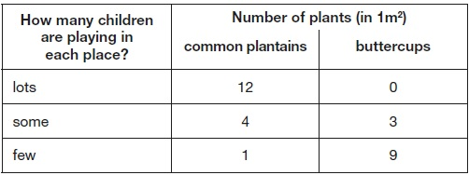
Describe the relationship between how many children are playing in a place and the number of common plantains found there.
___________________________________________________________________
___________________________________________________________________
1 mark
(d) The buttercup plant has a long thin stem.
The long thin stem of the buttercup plant stops it surviving in places where lots of children play. Explain why.
___________________________________________________________________
___________________________________________________________________
1 mark
Q3.
Seaweed and trees
(a) Maria found different types of seaweed on the beach.
Her teacher has a key to identify the seaweeds.
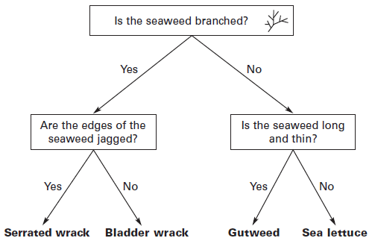
Use the key to identify the different seaweeds below.
Seaweed A has been done for you.
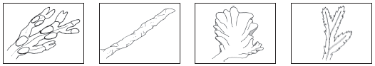
Seaweed A is Seaweed D is Seaweed C is Seaweed B is

Bladder wrack
........................... ........................... ............................ ...........................
1 mark
(b) Bladder wrack seaweed has pockets filled with gas. The pockets help it float near the surface of the water to get more sunlight.
Draw ONE arrow on the diagram to show the force from the water that makes the seaweed float near the surface of the water.
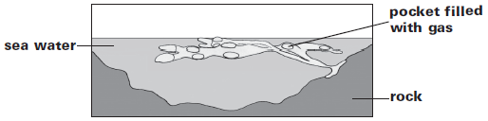
1 mark
(c) Trees also have features that help their leaves to get as much sunlight as possible.
Tick ONE feature of a tree and explain how this feature helps the leaves to get as much sunlight as possible.
trunk branches
How the feature helps the leaves to get sunlight: ..................................
.................................................................................................................
1 mark
(d) Seaweeds do not have roots. Trees do have roots.
Tick THREE boxes to show the functions of tree roots.

to make seeds |  | to absorb water
to anchor the plant in  the ground |  | to take up materials
to carry new material  for growth to the leaves |  | to protect the plant  from predators
1 mark

