Name:_______________________ Monday 20th November 2023
Class 5 Homework – Journey to the River Sea
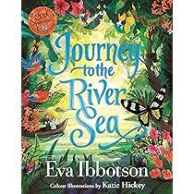
The next chapter…
Maia and Miss Minton have finally set off on their epic journey to the River Sea; Maia’s quest to meet and begin her new life in the Amazon Jungle with her unknown family – the Carters.
Maia has never been outside of London before – she has spent the last 2 years living in the Mayfair Academy for Young Ladies as her parents had sadly died. Miss Minton (The Governess) and Maia arrived in Liverpool and docked the Cardinal – a beautiful ship that will take them to Brazil (a 4 week journey)!
- What was the reaction of Maia when she saw the ship?
- How did Miss Minton warm towards Maia?
- Did Maia meet any new friends whilst aboard the Cardinal?
- What adventures could happen whilst on board for Maia?

Your homework this week is to write Chapter 2 where Maia and Miss Minton are aboard the Cardinal on their way to Brazil. Try to create as much atmosphere as possible using appropriate word / phase choices as well as a variety of punctuation.

