Science Homework – Class 5 – Alnwick – 22.1.24 Name:________________
Q1.
Sun
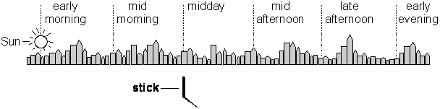

(a) The Sun is shining.
Its position early in the morning is shown in the picture.
Draw a Sun on each of the other dotted lines in the picture to show its height at the times given.
1 mark
(b) Why does the stick form a shadow when the Sun shines?
......................................................................................................................
......................................................................................................................
1 mark
(c) At what time would the shadow of the stick be shortest?
......................................................................................................................
1 mark
(d) Explain why the shadow is shortest at that time.
......................................................................................................................
......................................................................................................................
1 mark
(e) Why does the Sun appear to move across the sky?
......................................................................................................................
......................................................................................................................
1 mark

2 marks
Q2.
Shadow
(a) The children measured the length of the stick’s shadow at different times on a day in summer.
At 9 o’clock in the morning, the Sun is shining.
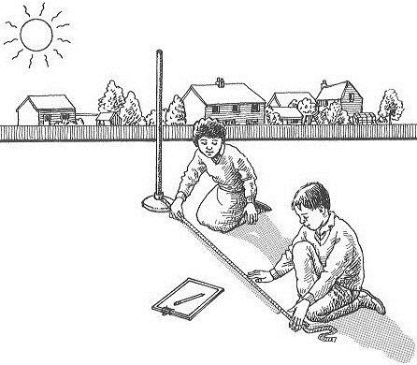
Explain how the shadow of the stick is formed.
......................................................................................................................
......................................................................................................................
1 mark
(b) At 3 o’clock in the afternoon, the sun appears to be in a different position in the sky.
Explain why the Sun appears to have moved.
......................................................................................................................
......................................................................................................................
1 mark
(c) At 7 o’clock in the evening the Sun appears to have moved further.
Which of the diagrams below shows the position of the shadow at 7 o’clock in the evening?
Tick ONE box.
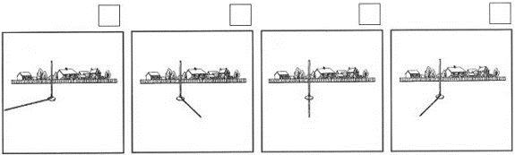
1 mark
(d) Debbie measured the length of a shadow at different times during the day.
She recorded her results.
Tick the box below which shows the length of the shadow at 2 pm.
Tick ONE box.

Time | Length of  shadow
10 am | 132 cm
11 am | 109 cm
12 am | 91 cm
1 pm | 80 cm
2 pm | ?
3 pm | 108 cm
81 cm 90 cm 105 cm 110 cm
1 mark
(e) Explain why the shadow was shortest at 1 mark pm.
......................................................................................................................
......................................................................................................................
1 mark

Q3.
The Earth
Sarah and Jack are using two different sized balls as models of the Sun and Earth.
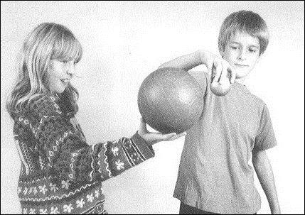
(a) The Earth spins on its axis.
Describe ONE other way the Earth moves in space.
......................................................................................................................
......................................................................................................................
1 mark
(b) How many times does the Earth spin on its axis in a day?
Tick ONE box.
1 7 24 28 365
1 mark
(c) Jack is now using the globe as a model of the Earth.
He uses the torch as a model of the Sun.
Three points A, B and C are marked on the globe.
The arrows in the picture show the way Jack turns the model of the Earth.
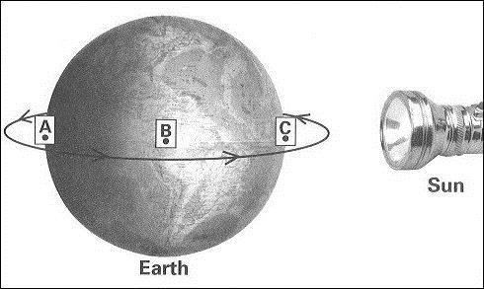
When the model Earth is in the position shown in the picture, what times of day are shown at A, B and C?
Choose ONE of the words below to complete each sentence.
Sunrise midday afternoon
Sunset midnight
One has been done for you.
At A it is midnight.
At B it is ..........................................................
1 mark
At C it is ..........................................................
1 mark
Q4.
Time on Earth
(a) Our measurements of time are linked to the movements of the Moon and Earth.
How many days does each of the following movements take?
Complete the table below.

Movement | Time taken (days)
Earth to spin on its axis.
Earth to orbit the Sun.
Moon to orbit the Earth.
2 marks
(b) Look at this diagram of the Sun and the Earth.
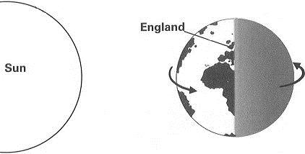
In the diagram above, what is the time in England?
Tick ONE box.
6 o'clock (morning) |  | 6 o'clock (evening)
12 o'clock (midday) |  | 12 o'clock (midnight)
1 mark
(c) The diagrams below show the same shadow stick at different times on the same day.
One circle on each diagram below shows the position of the Sun in the sky when each shadow is made.
(i) Put a cross in one circle on each diagram to show the correct position of the Sun.
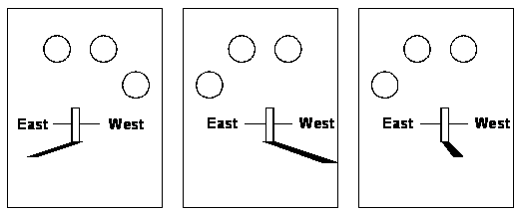
1 mark
(ii) Draw THREE lines below to match each shadow to the time it is made.
