Homework - Monday 8th January 2024 Name:
Alnwick
Amazing things about China

- What do you know about China?
Can you write as many things (using bullet points) about China.
Eg…Where is it on a globe; which continent is China; how big is China; What is the Capital City of China; Which seas are around China?...

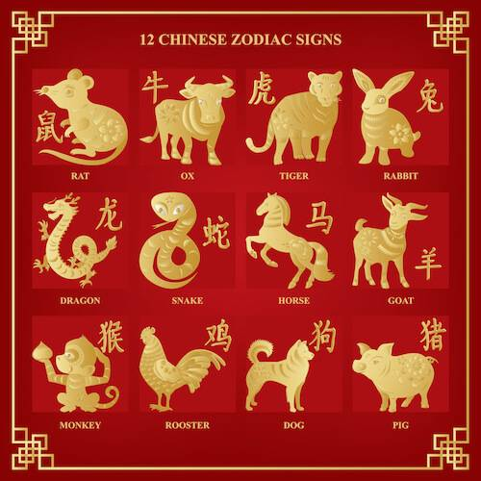
- Can you find information about The stories of the animals for the Chinese New Year?
- What does each sign represent?
- When were they created?
- Who created them?
- Why do the Chinese have different animals to mark each New Year?

Can you write a paragraph to explain your findings and discuss your thoughts?

