Monday 29th January 2024 Homework – Bamburgh & Alnwick

Literacy | 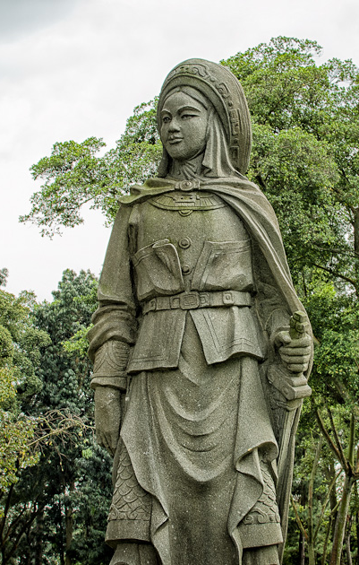  Writing – Other Cultures  The Statue  - What can you see?  - What clothing can you see?  - What accessories can you see?  - What facial expressions can you see?  - What occupation do you believe this person had?  - Why do you believe a statue has been made for this person?  Using the photo and question prompts above, can you write a detailed character description of the person.  Remember to include:  - An appropriate writing structure;  - Character description;  - Can you develop character emotions?  - Where did the person live?  - What did the person do for a living?  - Did they have any family?  - From which time era are they from?  Try to extend your writing by using:  - Adjectives  - Adverbs  - Similes and metaphors  - Subordinate, relative clauses…  - Accurate full range of punctuation  - Better word choices...  - Evaluate your writing and offer enhancements

