Science Homework – Class 5 – Bamburgh – 22.1.24 Name:________________
Q1.
Sun and Light
In daytime it is light.
At night it is dark.
Give two reasons why this happens.
Write your answer OR draw it using the diagram below.
WRITE HERE
...............................................................................................................................
...............................................................................................................................
...............................................................................................................................
2 marks
OR DRAW HERE
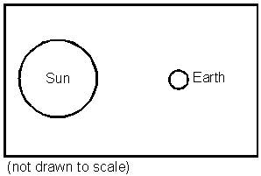
Q2.
Sun
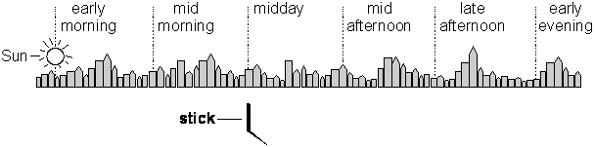

(a) The Sun is shining.
Its position early in the morning is shown in the picture.
Draw a Sun on each of the other dotted lines in the picture to show its height at the times given.
1 mark
(b) Why does the stick form a shadow when the Sun shines?
......................................................................................................................
......................................................................................................................
1 mark
(c) At what time would the shadow of the stick be shortest?
......................................................................................................................
1 mark
(d) Explain why the shadow is shortest at that time.
......................................................................................................................
......................................................................................................................
1 mark
(e) Why does the Sun appear to move across the sky?
......................................................................................................................
......................................................................................................................
1 mark
Q3.
The Earth
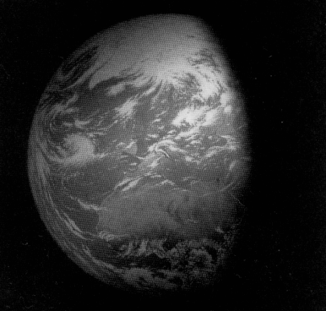
Complete the following sentences.
The Earth spins on its axis once every .............................. hours.
1 mark
The half of the Earth facing away from the Sun is in .............................
1 mark
It takes about 365 days for the Earth to orbit the ................................. .
1 mark
Q4.
Orbits
(a) The diagram shows the Sun, Earth and Moon (not drawn to scale).
Write Sun, Moon and Earth in the correct boxes on the diagram.
1 mark
(b) Two orbits are shown.
Write the time taken, in days, for each orbit.
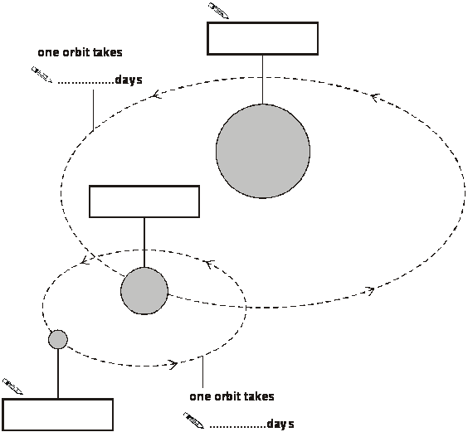
2 marks
Q5.
Shadow
(a) The children measured the length of the stick’s shadow at different times on a day in summer.
At 9 o’clock in the morning, the Sun is shining.
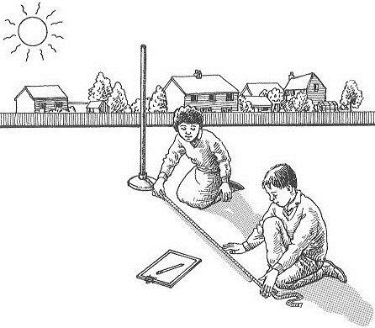
Explain how the shadow of the stick is formed.
......................................................................................................................
......................................................................................................................
1 mark
(b) At 3 o’clock in the afternoon, the sun appears to be in a different position in the sky.
Explain why the Sun appears to have moved.
......................................................................................................................
......................................................................................................................
1 mark
(c) At 7 o’clock in the evening the Sun appears to have moved further.
Which of the diagrams below shows the position of the shadow at 7 o’clock in the evening?
Tick ONE box.
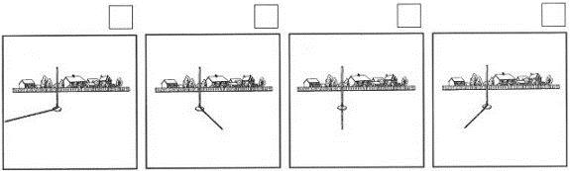
1 mark
(d) Debbie measured the length of a shadow at different times during the day.
She recorded her results.
Tick the box below which shows the length of the shadow at 2 pm.
Tick ONE box.

Time | Length of  shadow
10 am | 132 cm
11 am | 109 cm
12 am | 91 cm
1 pm | 80 cm
2 pm | ?
3 pm | 108 cm
81 cm 90 cm 105 cm 110 cm
1 mark
(e) Explain why the shadow was shortest at 1 mark pm.
......................................................................................................................
......................................................................................................................
1 mark

