Homework - Monday 8th January 2024 Name:
Bamburgh
Amazing things about China

- What do you know about China?
Can you write as many things (using bullet points) about China.
Eg…Where is it on a globe; which continent is China; how big is China; What is the Capital City of China; Which seas are around China?...

- Can you find information about How is Silk Made?
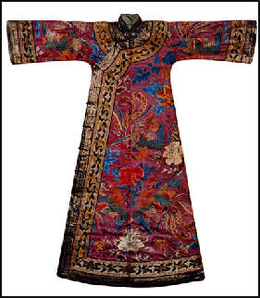
- Where does silk originate from?
- When was it first created?
- Who created it?
- Where on a map can the origins of silk be located?
- Who was silk made for and what was made from silk?
- Is silk still used today?

Can you write an information leaflet to explain your findings?

