Homework - Monday 8th January 2024 Name:
Lindisfarne
Amazing things about China

- What do you know about China?
Can you write as many things (using bullet points) about China.
Eg…Where is it on a globe; which continent is China; how big is China; What is the Capital City of China; Which seas are around China?...
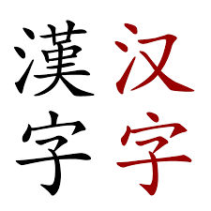
- Can you find information about Chinese writing?
- What does each sign represent?
- When were they created?
- Who created them?
- Can you explain how each symbol tells its story?
- Can you write a sentence using the symbols of Chinese writing?

Can you write a paragraph to explain your findings and discuss your thoughts?

