Science Homework – Class 5 Lumley – 22.1.24 Name:_______________
Q1.
The solar system
(a) Joe is finding out about the solar system.
He writes four statements about the Sun.
Write true or false next to each statement about the Sun.
 |  | True or False?
 | The Sun is a light source. | ____________
 | The Sun orbits the Earth. | ____________
 | The Sun is smaller than the Earth. | ____________
 | The Sun is a circle. | ____________
2 marks
(b) Joe finds out that days and years take different amounts of time on different planets.

Planet | Time for one day (Earth days) | Time for one year (Earth days)
Mercury | 59 | 88
Venus | 243 | 225
Earth | 1 | 365
Mars | 1 | 687
Jupiter | 0.4 | 4329
Look at the table.
(i) Which planet has the shortest day?
___________________________
1 mark
(ii) Which planet orbits the Sun quickest?
___________________________
1 mark

(c)
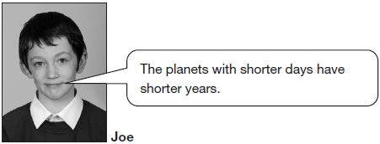
Look at the table above.
Do the planets with shorter days have shorter years? Tick ONE box.
 | yes |  |  | no
Use the information in the table to explain your answer.
___________________________________________________________________
___________________________________________________________________
1 mark
(d) All of the planets in our solar system have days and nights.
What movement in space causes day and night on Earth?
___________________________________________________________________
1 mark
Q2.
Famous scientist
(a) What shape is the Sun?
___________________________
1 mark
(b)
Galileo developed the equipment that scientists use to see the Sun, Moon, stars and planets in more detail. | 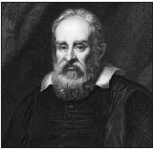  Galileo (1564–1642)
Name the equipment that scientists use to see into space.
___________________________________________________________________
1 mark
(c) The Moon orbits the Earth.
Tick ONE box to show how much time the Moon takes to orbit the Earth.
1 day |  | 24 days
28 days |  | 365 days
1 mark
(d) People used to think the Sun orbited the Earth because the Sun seems to move across the sky every day.
What movement in space makes the Sun seem to move across the sky every day?
___________________________________________________________________
1 mark
(e) Galileo believed the Earth orbited the Sun.
His observations into space gave evidence to support his idea.
Why is it important to get evidence to support a scientific idea?
___________________________________________________________________
___________________________________________________________________
1 mark
(f) Galileo said that the Earth stays in the same orbit as it travels around the Sun.
Write true or false next to each sentence to show what it would be like if the Earth’s orbit was further away from the Sun.

 | If the Earth’s orbit was further away from the Sun... | True or False?
 | the Earth would be colder. | ____________
 | the Earth would be darker. | ____________
 | the Earth would not have night-times. | ____________
 | the Earth would have longer years. | ____________
2 marks

Q3.
Space
(a) Adele’s class is learning about space.
Write Earth, Sun or Moon next to each sentence to show what it is describing.
It is a light source. ..............................
It takes 24 hours to spin on its axis. ..............................
Its orbit takes 28 days. ..............................
1 mark
(b)
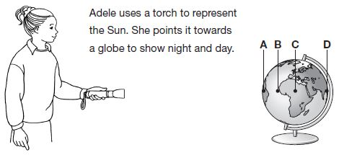
Draw FOUR lines below to show what time it would be at each place on the globe.
Place |  | Time
A |  | midnight
B |  | midday
C |  | 6 pm
D |  | 3 pm
2 marks

