Homework - Monday 8th January 2024 Name:
Lumley
Amazing things about China

- What do you know about China?
Can you write as many things (using bullet points) about China.
Eg…Where is it on a globe; which continent is China; how big is China; What is the Capital City of China; Which seas are around China?...

Can you find information about the Great Wall of China?
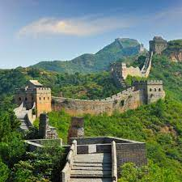
- Where is this famous landmark on a World Map?
- When was it built?
- Who built it?
- How long did it take to build?
- How many people did it take to build?
- What was the reasons for building it?

Can you write a brief paragraph to explain your findings?

