Homework - Monday 8th January 2024 Name:
Raby
Amazing things about China

- What do you know about China?
Can you write as many things (using bullet points) about China.
Eg…Where is it on a globe; which continent is China; how big is China; What is the Capital City of China; Which seas are around China?...

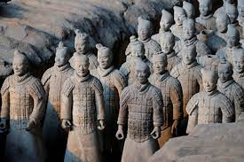
- Can you find information about The Terracotta Warriors?
- Where are these famous Warriors on a World Map?
- When were they built?
- Who built them?
- How long did they take to build?
- How many people did it take to build?
- What were the reasons for building them?

Can you write a brief paragraph to explain your findings?

