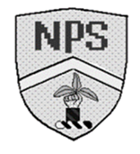Monday 5th February 2024 Homework – Alnwick
Q1.
Here is a square made from 4 smaller squares.
The area of the large square is 64cm².
What is the length of 1 side of each small square?
2 marks

Q2.
Lois has started drawing a shape on this squared-centimetre grid.
Complete her shape so that it has an area of 14cm².
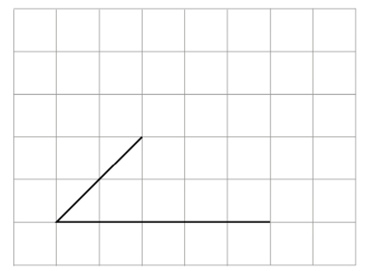
1 mark
Q3.
Grace has a rectangle that has sides of 4 cm and 5 cm.
Draw a different rectangle that has the same area.
1 mark

Q4.
Calculate the area of this triangle.
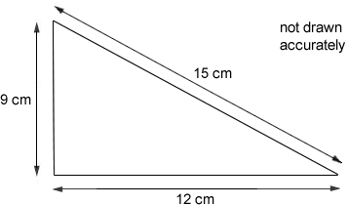
1 mark
Q5.
What is the perimeter of a square with an area of 64 cm²?
1 mark
Now give an example of another rectangle with an area of 64 cm² but a different perimeter.
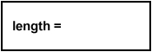
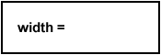
1 mark

Q6.
The diagram shows some shapes on a centimetre square grid.
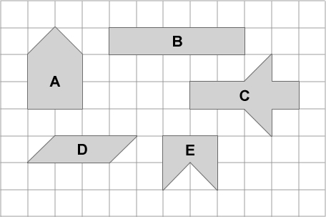
Which two shapes have the same area as shape A?
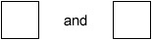
1 mark
Which two shapes have the same perimeter as shape A?
1 mark

Q7.

Here is a map of an island.
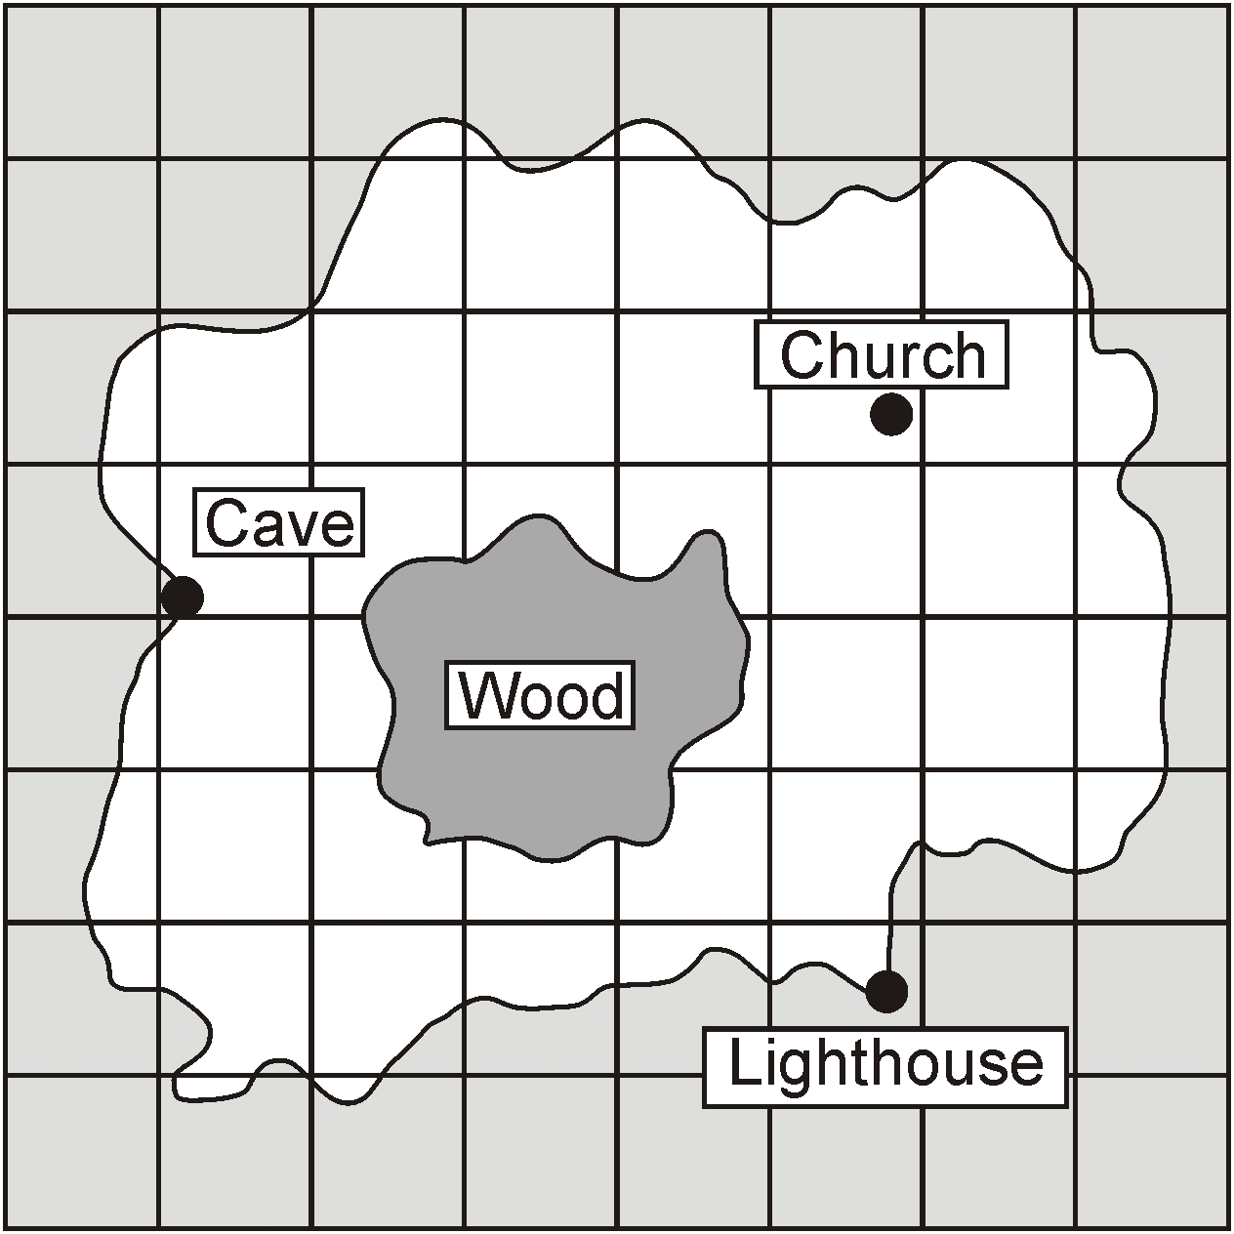
Estimate the area of the Wood.
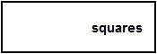
1 mark
A boat can safely carry 145 kilograms.

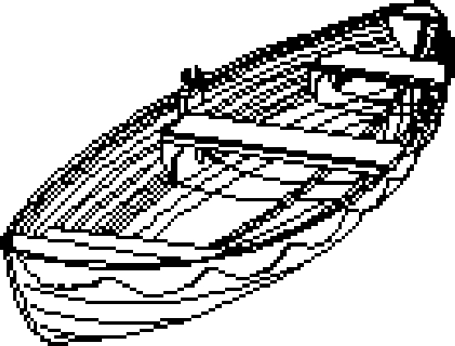
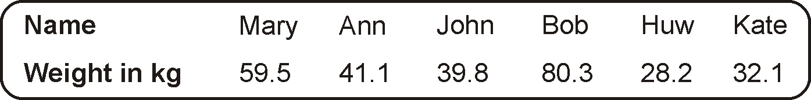
Work out if the boat can safely carry Mary and Bob.
You must show your working.

1 mark

Q8.

Here is a flag.

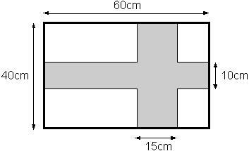
Calculate the area of the shaded cross.

2 marks

