Monday 5th February 2024 Homework – Bamburgh
Q1.

The area of a rugby pitch is 6,108 square metres.
A football pitch measures 112 metres long and 82 metres wide.
How much larger is the area of the football pitch than the area of the rugby pitch?

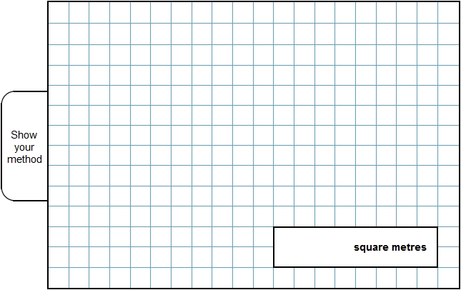
3 marks

Q2.

Here is a set of 20 squares around a shaded space.

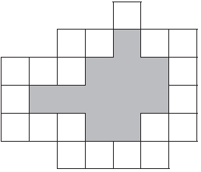
What is the area of the shaded space?
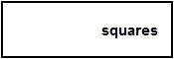
1 mark
Q3.

Megan says,
‘If two rectangles have the same perimeter,
they must have the same area.’
Is she correct?
Circle Yes or No.
Yes / No
Explain how you know.

1 mark

Q4.

Here is a T-shape made from 3 identical rectangles.
The area of the T-shape is 90 cm²

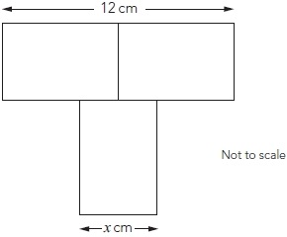
Work out the value of x

2 marks

Q5.

Here is a grid of regular hexagons.
The shaded shape has an area of 3 hexagons and a perimeter of 14 cm.
Draw another shape on the grid which has an area of 4 hexagons and a perimeter of 14 cm.

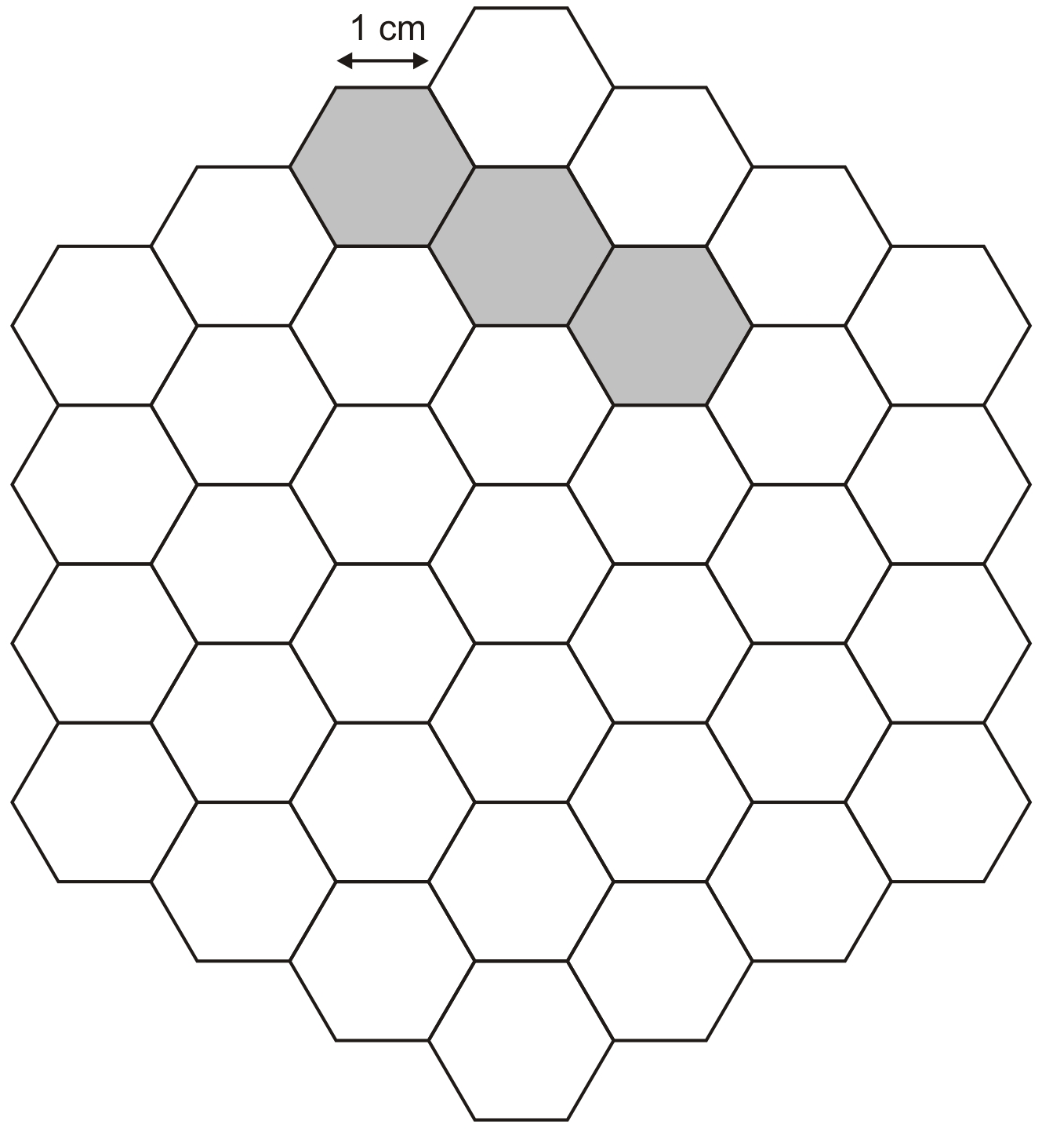
1 mark

Q6.

A white square is painted in one corner of a grey square.
Each side of the white square is half the length of a side of the grey square.

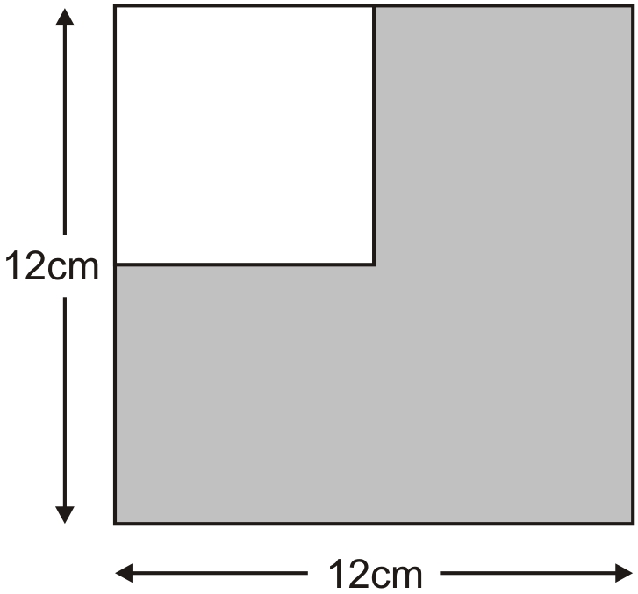
Not actual size
What is the area of the grey section?

