Monday 5th February 2024 Homework – Lindisfarne
Q1.

Here are five triangles on a square grid.
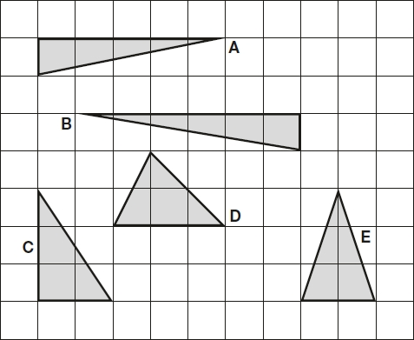
Four of the triangles have the same area.
Which triangle has a different area?
________________________
1 mark

Q2.

The area of this square is 36 cm².

The square is cut into quarters to create 4 identical rectangles.

What is the perimeter of one of the small rectangles?

2 marks

Q3.

Here is a set of 20 squares around a shaded space.

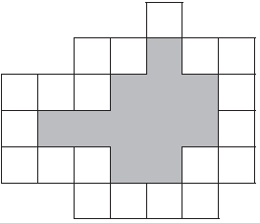
What is the area of the shaded space?
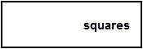
1 mark
Q4.

Here is a shaded shape on a 1 cm square grid.
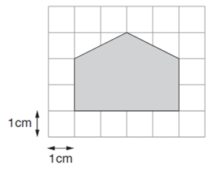
What is the area of the shaded shape?
1 mark

Q5.

The grid below is made of right-angled  triangles like this: | 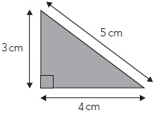
Shade triangles on the grid to make a quadrilateral.
Your quadrilateral must have an area of 24 cm^{2 and a perimeter of 26 cm.}

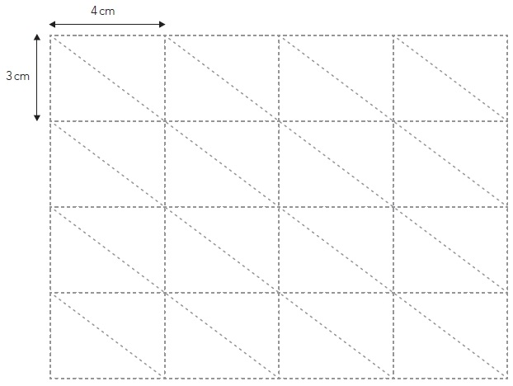
2 marks

Q6.

Lara has some identical rectangles.
They are 7 centimetres long and 2 centimetres wide.

She uses five of her rectangles to make the large rectangle below.

What is the perimeter of the large rectangle?
1 mark
What is the area of the large rectangle?
1 mark

