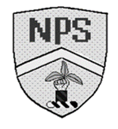Monday 5th February 2024 Homework – Raby & Lumley
Q1.

On the grid, draw a rectangle which has the same area as this shaded pentagon.
Use a ruler.

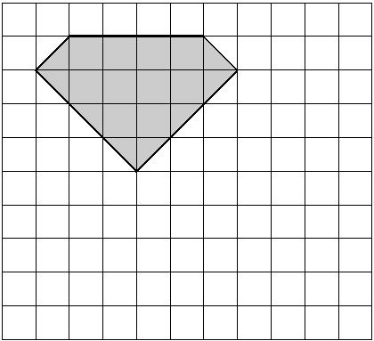
1 mark

Q2.

Here are some shapes on a 1cm square grid.

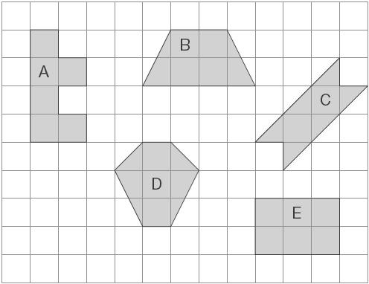
What is the perimeter of shape A?
1 mark
Write the letter of the shape that has the smallest area.
1 mark

Q3.

A line starts at A and goes along the dotted lines to B.
It divides the area of the grid into halves.

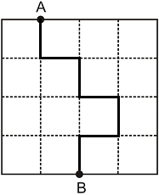
Divide the area of the grid below into halves. Start at A and go along the dotted lines to B.

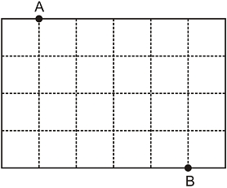
1 mark

Q4.

Rebecca has rectangular tiles like this.
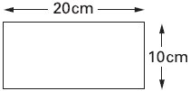 Not to scale
She makes a larger rectangle using 4 of the tiles.

What is the area of the larger rectangle?
1 mark
Q5.

The area of a rectangle is 16 cm².
One of the sides is 2 cm long
What is the perimeter of the rectangle?
1 mark

