Science Homework – Electricity – Alnwick – 11.3.24
Q1.
Electricity
(a) Some children make this circuit to light a bulb.
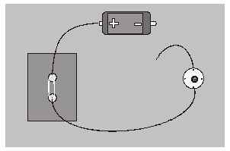
The bulb is not lit.
Why is the bulb not lit?
......................................................................................................................
......................................................................................................................
1 mark
(b) The children make another circuit to light a bulb.
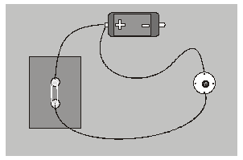
The bulb is not lit.
Why is the bulb not lit?
......................................................................................................................
......................................................................................................................
1 mark
(c) Here are two photographs of circuits and five circuit diagrams.
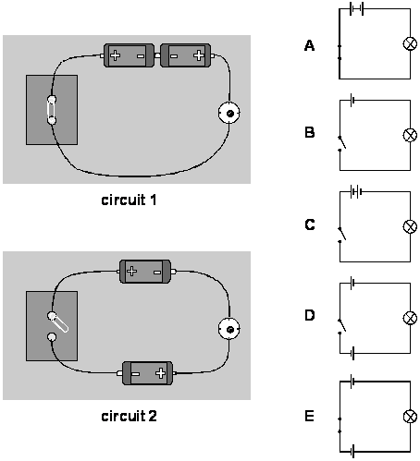
2 marks
Draw ONE line from each photograph to the matching circuit diagram.
(d) The bulb is not lit in circuit 2.
Why is the bulb not lit?
......................................................................................................................
......................................................................................................................
1 mark

Q2.
Circuits
(a) Two children made a model fairground ride.
They connected a battery to an electric motor to make the model turn.
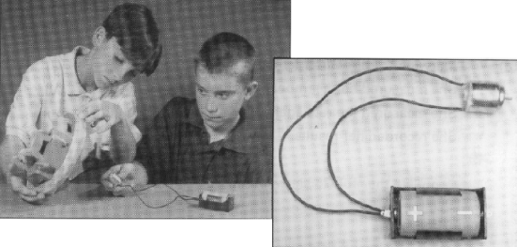
The motor is not working.
What is wrong with this circuit?
......................................................................................................................
......................................................................................................................
1 mark
(b) Draw a circuit diagram in which the switch can be used to turn the motor on and off.
You MUST use these three symbols in your diagram.
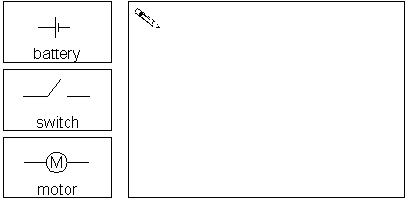
1 mark
(c) Here are two different circuits which use the same kind of battery and bulb.
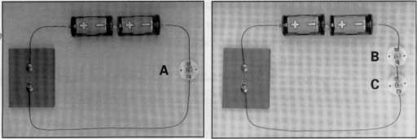
Which bulb will be the brightest ?
Tick ONE box.
bulb A bulb B bulb C
1 mark
(d) The outside of this plug is made of plastic so that you do not get a shock when
you plug it in.
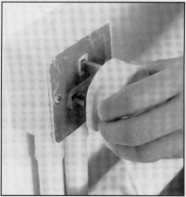
Explain why the plastic helps to make the plug safe.
......................................................................................................................
1 mark
(e) Why is it dangerous to put a plug in when the plug is wet?
......................................................................................................................
......................................................................................................................
1 mark

Q3.
Bright Lights
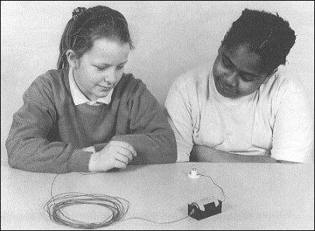
(a) Jill made circuits with different lengths of wire, the same battery and the same bulb. The wire is coated in plastic.
She recorded her results in a table.

lenght of  wire (m) | brightness of light  from bulb
40 | no light
30 | dim glow
20 | faint light
10 | bright light
1 | very bright light
Look at the table.
Describe how changing the length of the wire in the circuit affects the brightness of the light.
......................................................................................................................
......................................................................................................................
2 marks
(b) Sharon had the same kind of wire.
She wanted to know how much wire she had on her reel.
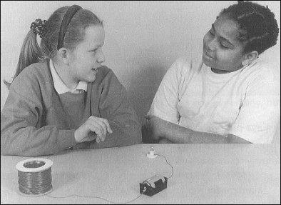
When the reel of wire was connected into the same circuit there was a faint light from the bulb.
Use the information from the table.
How much wire was on the reel when there was a faint light from the bulb?
Tick ONE box
less than 5 m 5 – 15 m 15 – 25 m
25 – 30 m more than 40 m
1 mark

Q4.
Circuits
(a) Lisa and James are testing different materials in a circuit.
When they connect a steel fork in the circuit, the bulb lights.
They put three other objects in the circuit, one at a time.
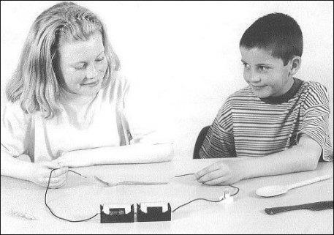
Complete the table of results, to show what they found, by putting ONE tick for each object.
One has been done for you.
 | bulb  lights | bulb  does not  light
steel fork
plastic comb
wooden spoon
aluminium foil
1 mark
(b) Daniel has made a circuit.
The circuit contains one new battery, two new bulbs and a switch.
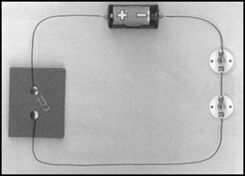
The bulbs are not lit in Daniel’s circuit.
Why are the bulbs not lit in this circuit?
......................................................................................................................
1 mark
(c) Draw a circuit diagram of Daniel’s circuit. Use these symbols.
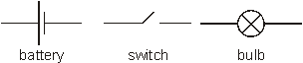
1 mark

