Science Homework – Electricity – Bamburgh – 11.3.24
Q1.
Quiz board
(a) Lori makes an electrical quiz board like the one below.
She writes a question on the flap of paper.
Then she writes four answers next to the letters A, B, C and D.
Only one answer is correct.
When the wire touches the metal clip next to the correct answer, the bulb lights brightly.
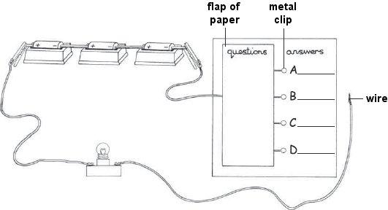
When she lifts the flap of paper, you can see how the circuit is made.
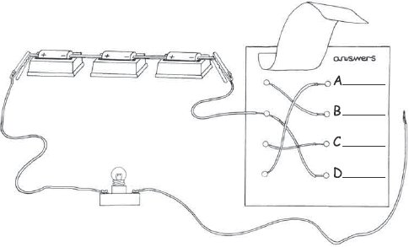
Look at the diagrams.
Which metal clip must Lori touch with the wire to complete the circuit? Tick ONE box.
A B C D
1 mark
(b) Lori removes one cell (battery) from her circuit.
How will taking one cell out of Lori’s circuit affect the bulb when it is lit?
.......................................................................................................................
1 mark
(c) Lori tries to improve the quiz board. She puts sticky tape over the metal clips A, B, C and D to keep them in place.
She tests the quiz board. It does not work.
Explain why the sticky tape stops Lori’s quiz board from working.
.......................................................................................................................
........................................................................................................................
1 mark
Q2.
Train in the tunnel
(a) Andrea wants a light bulb to light up when her toy train is pushed through a tunnel. She makes an electric circuit for her toy train.
Andrea makes a tunnel and puts a strip of foil inside the tunnel roof.
The picture shows Andrea’s tunnel and the wiring on her train.
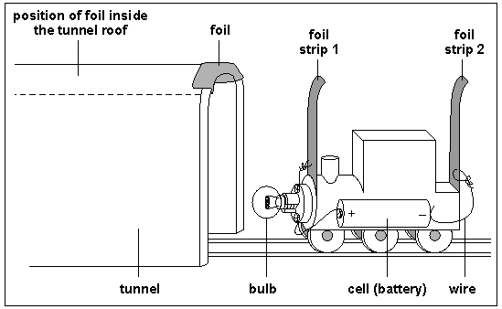
The foil strips on the train act like a switch. When both foil strips on the train touch the foil inside the tunnel roof, the bulb lights up.
Complete the circuit diagram below by drawing the switch and the bulb to show the circuit on Andrea’s train.
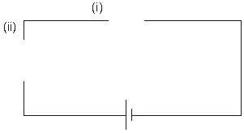
2 marks
(b) Give ONE property of metal foil which makes it a good material for Andrea to use as a switch.
.....................................................................................................................
1 mark
(c) When only one foil strip on the train is touching the foil in the tunnel, the bulb does not light up.
Complete the sentence to explain why the bulb does not light up.
The circuit ...................................................................................................
1 mark
(d) The bulb on the train only lights up when all of the train is inside the tunnel.
Andrea wants to improve her circuit so the bulb lights up when the train has only just entered the tunnel.
Which train has foil strips that would allow the bulb to light when the train has only just entered the tunnel?
Tick ONE box.
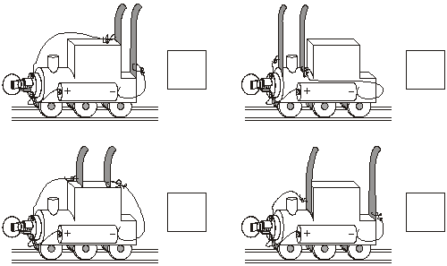
1 mark
Q3.
Electricity
(a) Shana builds the three circuits below. All the equipment works.
The bulbs in the circuits are not lit up.
Complete each sentence to explain why the bulb has not lit in each circuit.
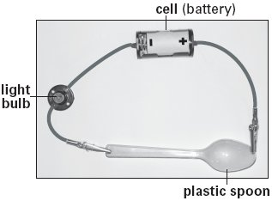
The bulb has not lit because the plastic spoon ............................................
......................................................................................................................
1 mark
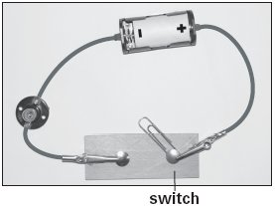
The bulb has not lit because ........................................................................
......................................................................................................................
1 mark
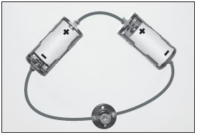
The bulb has not lit because ........................................................................
......................................................................................................................
1 mark
(b) Andy builds the circuit below. The bulbs do light up.
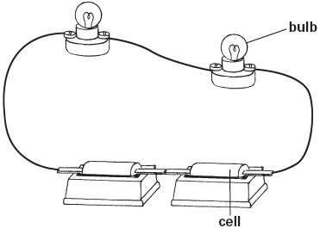
Draw a circuit diagram for Andy’s circuit in the space below.
Use these symbols in your circuit diagram:
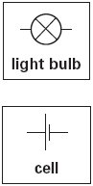
1 mark
(c) Andy wants to change his circuit so that the two bulbs are brighter.
He can use any other equipment.
Suggest TWO ways Andy can make his two bulbs brighter.
1. ..................................................................................................................
1 mark
2. ..................................................................................................................
1 mark
Q4.
Circuits and sensors
(a) Class 6D makes different circuits using the same type of bulbs, motors with fans and cells (batteries).
(i) Tick ONE box to show the circuit in which the bulb or bulbs are brightest.
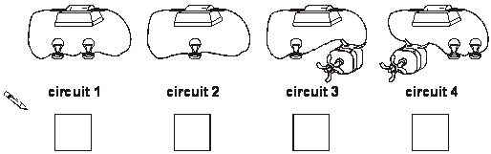
1 mark
(ii) Explain why the circuit you chose has the brightest bulb or bulbs.
............................................................................................................
............................................................................................................
1 mark
(b) Tick ONE box to show which circuit diagram below is correct for circuit 3.
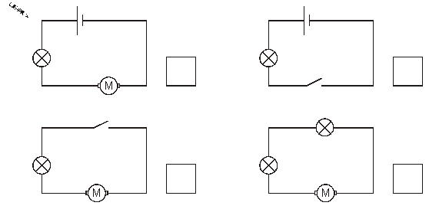
1 mark
7
(c) Each of the circuits made by class 6D has one cell.
Complete the sentence below to explain the effect on the bulbs of adding a second cell to circuit 1.
The bulbs will ...............................................................................................
1 mark
(d) Class 6D made three new circuits. They used a light sensor to measure the brightness of one of the bulbs in each circuit.
The sensor gave the results on the graph below.
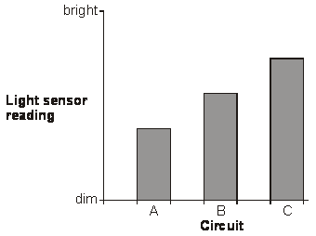
1 mark
Write A, B or C next to each circuit below to show which circuit gave each light sensor reading on the graph.
circuit .................... circuit .................... circuit ....................
1 mark

