Science Homework – Electricity – Raby & Lumley – 11.3.24
Q1.
Electricity investigation
(a) Lena has this equipment:
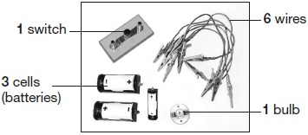
Tick THREE boxes to show which questions Lena could investigate using only the equipment shown above.
Tick THREE boxes.
Do different cells affect the brightness of a bulb?
How many bulbs can be lit by one cell?
Does the number of cells affect the brightness of a bulb?
Does the number of switches affect the brightness of a bulb?
Does the direction of cells affect the brightness of a bulb?
2 marks
(b) Draw FOUR lines to match the electrical components to their symbols.
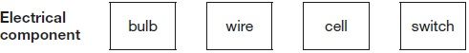
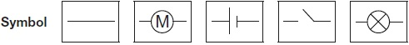
1 mark
(c) Lena collected these wires.
The wires are made of different metals.
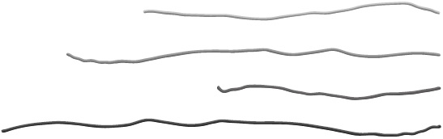
Lena says, ‘I want to know if the wires made of different metals will change the brightness of the bulb in the circuit.’
What must Lena do to the wires to make her test fair?
___________________________________________________________________
1 mark
(d) Lena makes her test fair.
Tick TWO boxes to show the two pieces of evidence Lena should collect for her results.
Tick TWO boxes.
how quickly the bulb lights up |  | how bright the bulb is
how many wires there are |  | what metals the wires are made of
1 mark
Q2.
Lighthouse

(a) | George makes a model lighthouse using a cardboard tube and a yoghurt pot.  He makes a circuit to make his lighthouse light up.  The yoghurt pot lets some light through. | 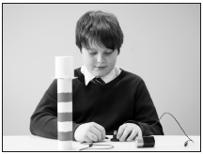
What is the name given to a material that lets only some light through?
___________________________
1 mark
(b) George wants to make his lighthouse have a brighter light.
Tick ONE box to show what George could use instead of a yoghurt pot to make the lighthouse appear brighter.
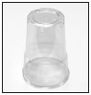 | plastic cup |  | 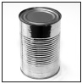 | tin can
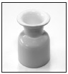 | china egg cup |  | 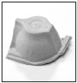 | part of cardboard egg box
1 mark
(c) George uses one bulb, one cell (battery) and two wires to make the circuit for his lighthouse.
Draw the circuit diagram using the correct symbols for the lighthouse.
2 marks
(d) Write true or false next to each sentence about the circuit.

 | George’s circuit will only work if... | True or False?
 | the cell is connected to the bulb. | ____________
 | there are gaps in the circuit. | ____________
 | he uses wires of the same length. | ____________
 | the wires are connected to the same end of the cell. | ____________
2 marks
(e) What component should George add to his circuit to make the light brighter?
___________________________________________________________________
1 mark
Q3.
Model house
(a) A group of children are making a circuit for a door bell and lights in a model house.
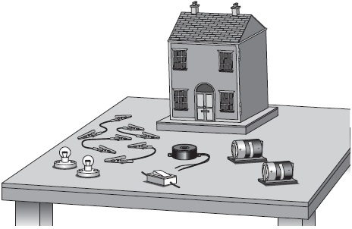
The circuit symbols for the parts used in the circuit are shown below.
Write the name of each part next to its circuit symbol.
One is done for you.
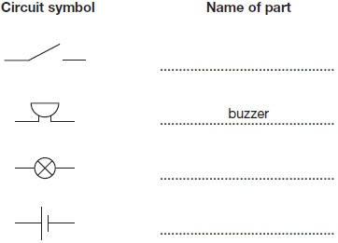
2 marks
(b) The children make this circuit.
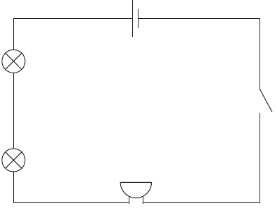
(i) What must the children do to their circuit to turn the light bulbs and the buzzer on?
................................................................................................................
1 mark
(ii) The buzzer only makes a quiet sound.
How could the children change the circuit to make the
buzzer louder? Give TWO ways.
1 ..............................................................................................................
2 ..............................................................................................................
2 marks

