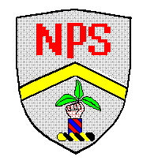
Nettlesworth Primary School
Front Street
Nettlesworth
Chester le Street
Durham

3rd March 2025
Welcome back to Spring 2!

Dear Parents and Carers,

Welcome back to school everyone and to Spring 2! I hope you have enjoyed your break and are looking forward to the new half term.

In Class 4, we are looking forward to having lots of fun learning new things and consolidating our learning from last term. This half term our new Cornerstones topic is ‘1066’. We’ll be looking at the Norman Conquest of England, learning all about the battle for the throne and the Battle of Hastings! Please keep an eye on our section of the school website to find out about all the exciting things we are doing in class.

Just a few notes for your diary:

Homework given out on Mondays and is expected back in school on Fridays. Children’s homework can also be uploaded to DB. Spellings are given out on Wednesdays for our spelling tests on Mondays.

Finally, PE kits! Please send in a PE kit on a Monday and leave it at school throughout the week. We will return this home on a Friday. Our PE days change each half term depending on available coaches in school.

If you have any questions please feel free to ask.

Many Thanks,

Mrs Edwards

