**Science Homework – Lumley – 16.6.25 Name:__________________________**

**Q1.**

**Sports day**

(a)     Dan has some ideas about exercise.

Write **true** or **false** under each statement about exercise.



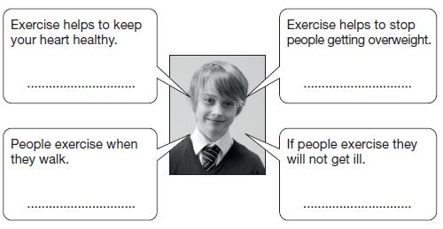

2 marks

(b)     Leg muscles and bones help people to run and move.  
Leg bones are part of the skeleton.

Other than movement, describe **another** function of the skeleton.

  ........................................................................................................................

1 mark

(c)     Dan wins the 100 m race at his school’s sports day. He gets a medal.

|  |  |
| --- | --- |
| The school’s medals are made of **steel** or **plastic**.  They are all the same size, shape and colour.  Dan tests his medal to find out if it is steel or plastic. |  |

Will each test show if Dan’s medal is steel or plastic?  
Write **yes** or **no** in each row of the table below.



|  |  |
| --- | --- |
| **Test** | **Will the test show if Dan’s medal is steel or plastic? Yes or no?** |
| Hold a magnet next to each medal. |  |
| Put each medal in an electric circuit with a bulb and cell. |  |
| Drop some water on each medal. |  |
| Weigh each medal. |  |
| Shine a light on each medal. |  |

2 marks

**Q3.**

**Pulse rate**

(a)     Class 6 are learning about the human body.

Complete the sentences below using the words in the box.



  The ............................... pumps blood around the body.

The ............................... carry blood around the body.

The ............................... protect the heart.

1 mark

(b)     Your pulse rate tells you how fast your heart is beating.

Tick **ONE** box to show what equipment you could use to workout your pulse rate.



|  |  |  |  |
| --- | --- | --- | --- |
| ruler |  | forcemeter |  |
| stopwatch |  | thermometer |  |

1 mark

(c)     Class 6 have some ideas about pulse rate.

Write **true** or **false** next to each statement about pulse rate.



|  |  |
| --- | --- |
|  | **True** or **false?** |
| Different types of exercise can affect pulse rate by different amounts. | ...................... |
| Different people can have different resting pulse rates. | ...................... |
| A high pulse rate means the heart is beating fast. | ...................... |

1 mark

(d)     Class 6 investigate the effect of exercise on pulse rate.  
They measure Emily’s pulse rate three times:

|  |  |
| --- | --- |
| 1.      at rest.  2.      straight after running for          10 minutes.  3.      after resting for 20 minutes. |  |

Look at the table of results below.  
Some of Emily’s pulse rates are missing.

Complete the table of results by predicting Emily’s pulse rates straight after running and after resting for 20 minutes.



|  |  |  |  |
| --- | --- | --- | --- |
|  | **At rest before running** | **After running for 10 minutes** | **After resting for 20 minutes** |
| **Pulse rate (heart beats per minute)** | 90 | ...................... | ...................... |

1 mark

(e)     Class 6 think of some questions about the heart and exercise.

Tick **THREE** boxes to show which questions the class could investigate by doing a fair test.



|  |  |
| --- | --- |
| Where is the heart found in the body? |  |
| How does age affect a person’s heart rate? |  |
| How does the heart work? |  |
| What does the heart look like? |  |
| Do tall people have faster pulse rates than short people? |  |
| Do people who exercise regularly eat more food than people who do not exercise? |  |

2 marks

**Q4.**

**Animal heart rates**

(a)     Some children found out about the heart rate of some fully grown animals.

|  |  |  |
| --- | --- | --- |
| **Fully grown animal** (drawings not to scale) | **Average mass of animal (kg)** | **Average heart rate (beats per minute)** |
| elephant | 3000 | 35 |
| human | 68 | 70 |
| cat | 7 | 130 |
| rabbit | 4 | 205 |
| squirrel | 0.5 | 400 |

Use the table to answer the next three questions.

(i)     Which fully grown animal has the fastest average heart rate?

  ......................................................

(ii)     What is the average mass of a fully grown cat?

  ...................................................... kg

(iii)     What is the average heart rate of the fully grown animal whose mass is 4 kg?

  ...................................................... beats per minute

2 marks

(b)     Describe the relationship between the **mass** of the animal and **heart rate** shown in this table.

  .................................................................................................................

.................................................................................................................

1 mark

(c)     This dog has a mass of 30 kg.

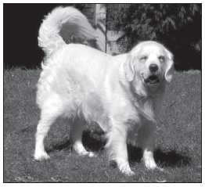

Predict the heart rate of this dog.  
Use the table to help you.

 ...................................................... beats per minute

1 mark